National Inter schools Show Jumping Championships
Saturday 21st & Sunday 22nd April 2012
Incorporating the Equestrian Inter schools Hoofprints.ie League final

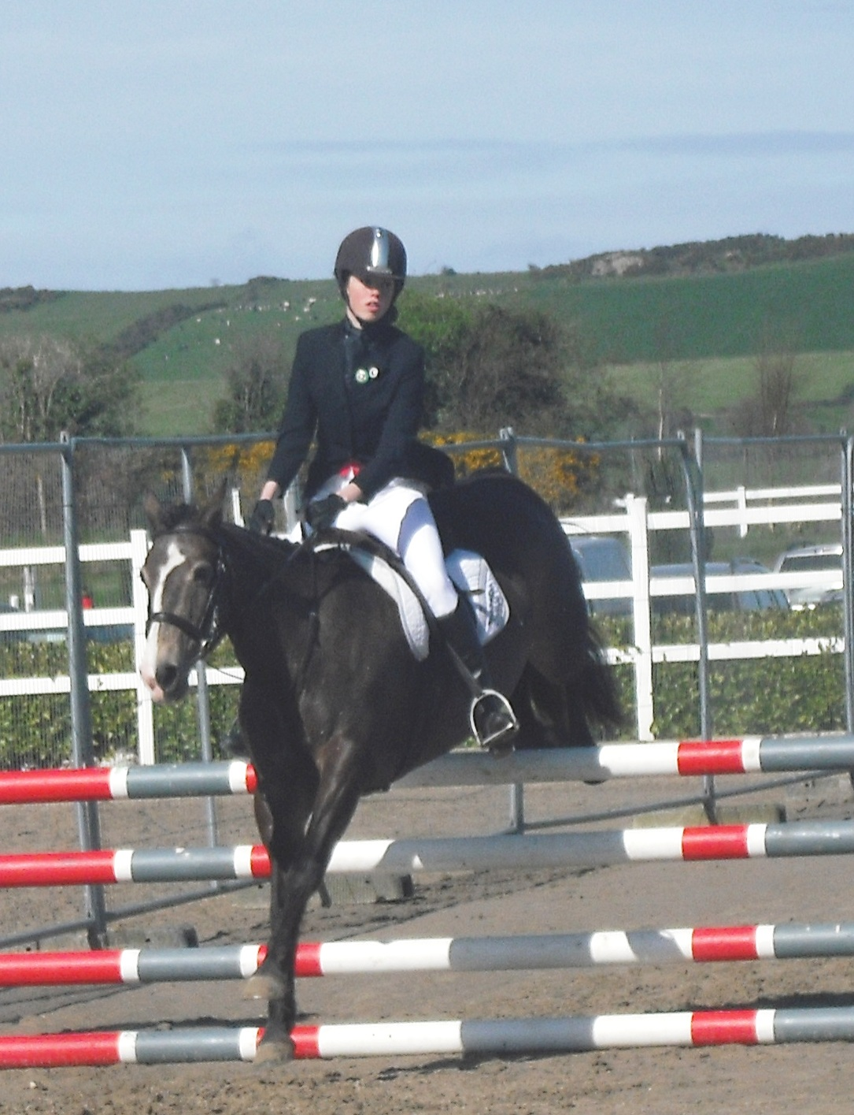

Venue: Mullingar Equestrian Centre
Enquiries to 087-2488018 or 086-8269334
Entry Forms & schedule on
www.mullingarequestrian.com or www.equestrianinterschools.com
All team entries close on Monday April 16th 2012

9 NATIONAL TITLES TO BE WON ( Classes for Secondary & Primary Schools)
- National Open Team Champions National Individual Champion
- National Novice Team Champions National Novice Individual Champion
- National Hoofprints League Team Champions National Hoofprints Individual Champion
- National Primay Sch Team Champions National Primary Individual Champion
- National Novice /Open Jump Cross Champion


